Практическая работа 7
Тема: «Построение дерева решений»

Цель: научиться создавать и визуализировать дерево решений для анализа и принятия оптимальных управленческих решений в различных ситуациях.

Ход работы
Вариант 12

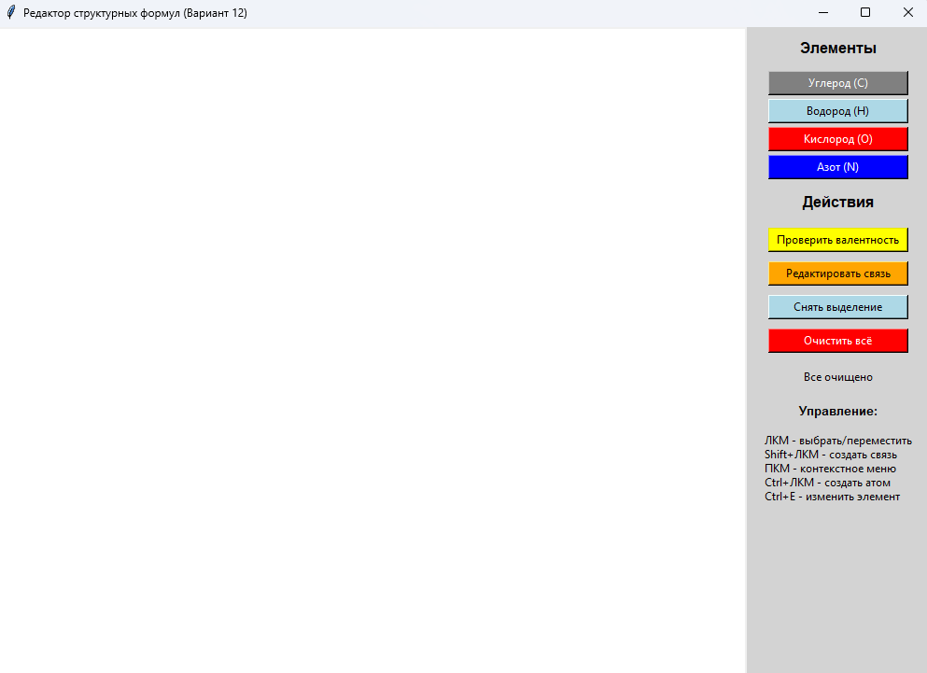Рис. 1 – Начальный экран

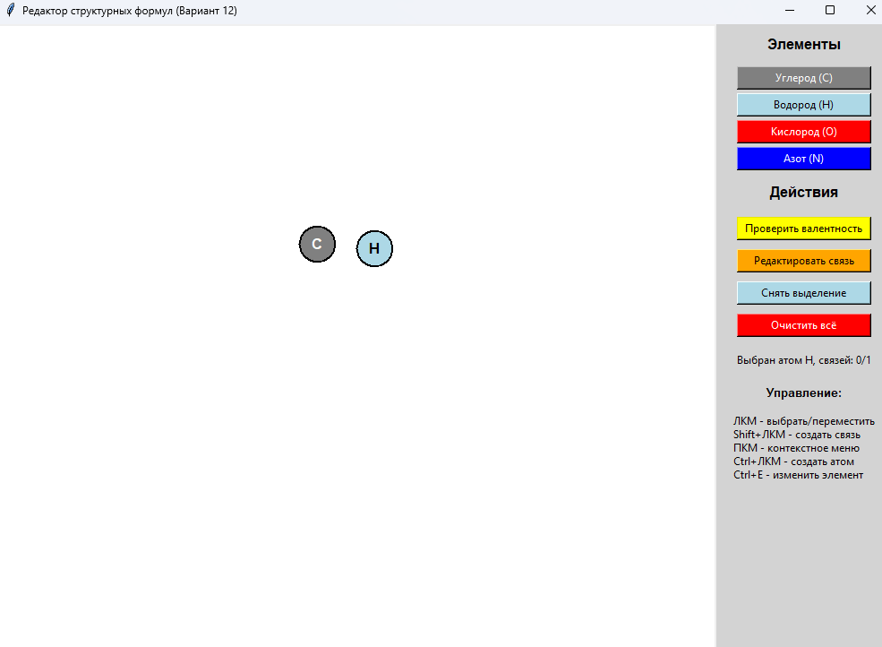
Рис. 2 – Добавлены элементы

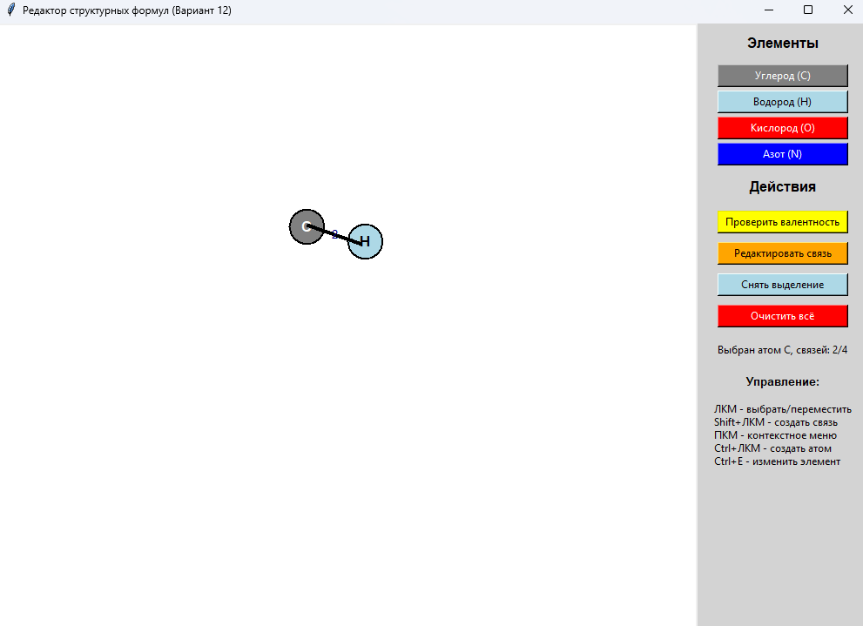
Рис. 3 – Добавлена связь

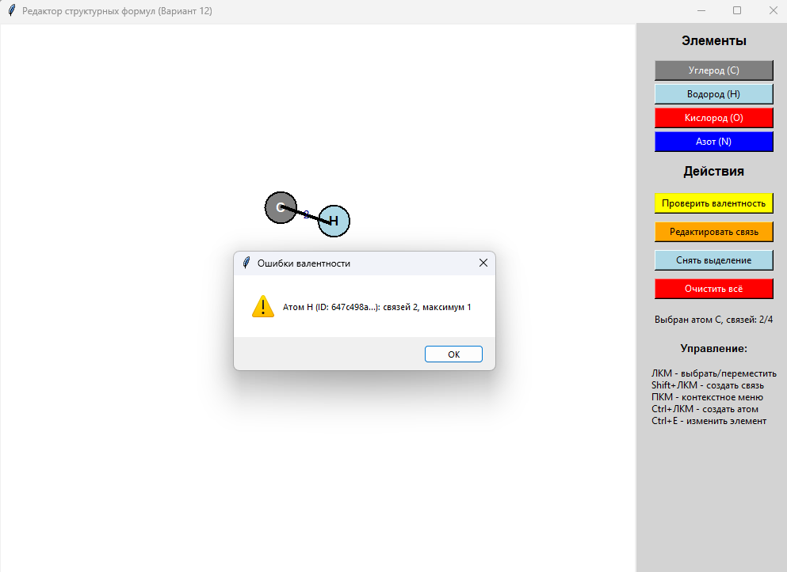
Рис. 4 – Проверка валентности

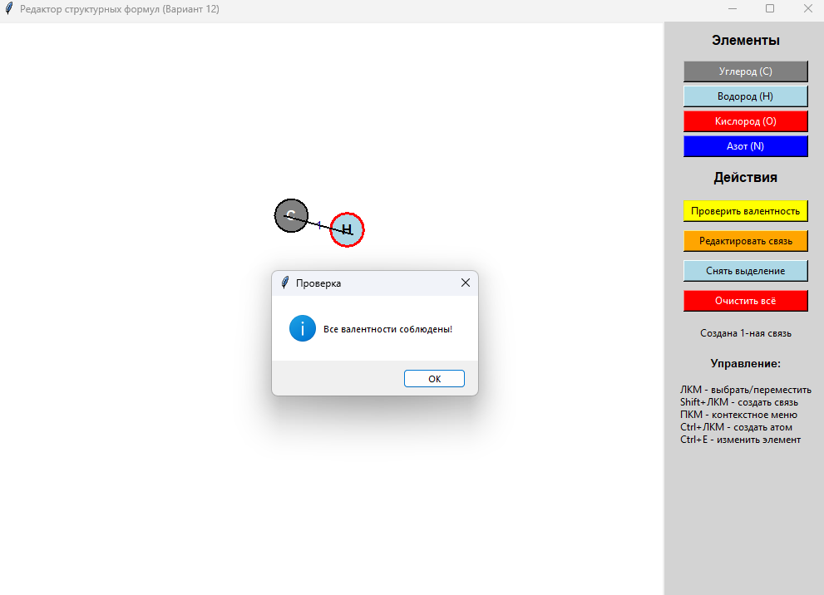
Рис. 5 – Проверка валентности с 1 связью

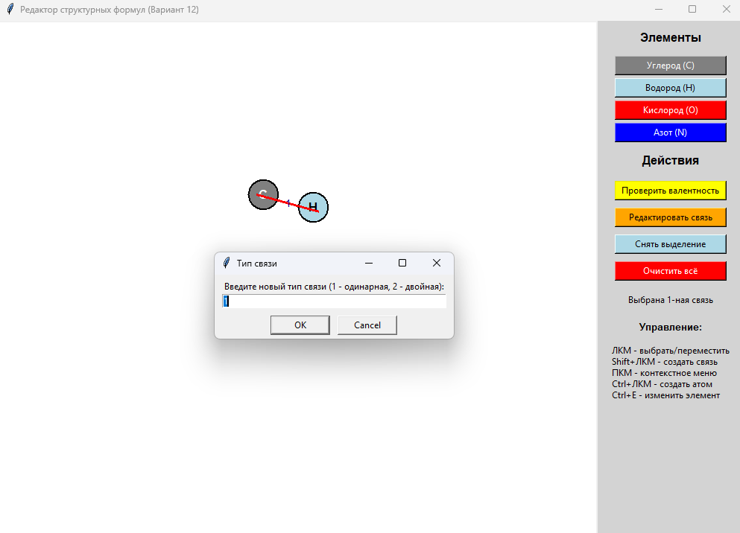
Рис. 6 – Редактирование связи

Приложение А:
import tkinter as tk
from tkinter import messagebox, simpledialog
import math
import uuid

class Atom:
def __init__(self, x, y, element='C', name=None):
self.id = str(uuid.uuid4())
self.x = x
self.y = y
self.element = element
self.name = name if name else element
self.canvas_id = None
self.text_id = None
self.selected = False
self.connections = []
self.bond_count = 0

def get_valence(self):
valence_dict = {'C': 4, 'H': 1, 'O': 2, 'N': 3}
return valence_dict.get(self.element, 4)

class Bond:
def __init__(self, atom1, atom2, bond_type=1):
self.id = str(uuid.uuid4())
self.atom1 = atom1
self.atom2 = atom2
self.bond_type = bond_type
self.canvas_id = None
self.text_id = None
self.selected = False

class MoleculeEditor:
def __init__(self, root):
self.root = root
self.root.title("Редактор структурных формул (Вариант 12)")
self.root.geometry("1000x700")

self.atoms = []
self.bonds = []
self.selected_atom = None
self.selected_bond = None
self.temp_bond_atom = None
self.drag_data = None
self.current_element = 'C'
self.atom_radius = 20

self.setup_ui()
self.setup_bindings()

def setup_ui(self):
self.canvas = tk.Canvas(self.root, bg='white', width=800, height=600)
self.canvas.pack(side=tk.LEFT, fill=tk.BOTH, expand=True)

control_panel = tk.Frame(self.root, width=200, bg='lightgray')
control_panel.pack(side=tk.RIGHT, fill=tk.Y)
control_panel.pack_propagate(False)

tk.Label(control_panel, text="Элементы", bg='lightgray', font=('Arial', 12, 'bold')).pack(pady=10)

elements = [('Углерод (C)', 'C', 'gray'), ('Водород (H)', 'H', 'lightblue'),
('Кислород (O)', 'O', 'red'), ('Азот (N)', 'N', 'blue')]
for text, elem, color in elements:
btn = tk.Button(control_panel, text=text, bg=color, fg='white' if elem!='H' else 'black',
width=20, command=lambda e=elem: self.set_current_element(e))
btn.pack(pady=2)

tk.Label(control_panel, text="Действия", bg='lightgray', font=('Arial', 12, 'bold')).pack(pady=10)

tk.Button(control_panel, text="Проверить валентность", bg='yellow', width=20,
command=self.check_valence).pack(pady=5)

tk.Button(control_panel, text="Редактировать связь", bg='orange', width=20,
command=self.edit_selected_bond).pack(pady=5)

tk.Button(control_panel, text="Снять выделение", bg='lightblue', width=20,
command=self.deselect_all).pack(pady=5)

tk.Button(control_panel, text="Очистить всё", bg='red', fg='white', width=20,
command=self.clear_all).pack(pady=5)

self.status_label = tk.Label(control_panel, text="Готов к работе", bg='lightgray', wraplength=180)
self.status_label.pack(pady=10)

tk.Label(control_panel, text="Управление:", bg='lightgray', font=('Arial', 10, 'bold')).pack(pady=5)
tk.Label(control_panel, text="ЛКМ - выбрать/переместить\nShift+ЛКМ - создать связь\nПКМ - контекстное меню\nCtrl+ЛКМ - создать атом\nCtrl+E - изменить элемент",
bg='lightgray', justify=tk.LEFT).pack(pady=5)

def setup_bindings(self):
self.canvas.bind("<Button-1>", self.on_left_click)
self.canvas.bind("<Button-3>", self.on_right_click)
self.canvas.bind("<Shift-Button-1>", self.on_shift_click)
self.canvas.bind("<Control-Button-1>", self.on_ctrl_click)
self.canvas.bind("<B1-Motion>", self.on_drag)
self.canvas.bind("<ButtonRelease-1>", self.on_drag_end)
self.canvas.bind("<Motion>", self.on_mouse_move)
self.root.bind("<Control-e>", self.on_ctrl_e)
self.root.bind("<Control-E>", self.on_ctrl_e)

def set_current_element(self, element):
self.current_element = element
color = {'C': 'серый', 'H': 'голубой', 'O': 'красный', 'N': 'синий'}.get(element, '')
self.update_status(f"Выбран элемент: {element} ({color})")

def find_atom(self, x, y):
for atom in self.atoms:
if math.sqrt((atom.x - x)**2 + (atom.y - y)**2) <= self.atom_radius:
return atom
return None

def find_bond(self, x, y):
for bond in self.bonds:
x1, y1 = bond.atom1.x, bond.atom1.y
x2, y2 = bond.atom2.x, bond.atom2.y

line_length = math.sqrt((x2 - x1)**2 + (y2 - y1)**2)
if line_length == 0:
continue

distance = abs((y2 - y1)*x - (x2 - x1)*y + x2*y1 - y2*x1) / line_length

if distance <= 5:
t = ((x - x1)*(x2 - x1) + (y - y1)*(y2 - y1)) / (line_length**2)
if 0 <= t <= 1:
return bond
return None

def create_atom(self, x, y):
if self.find_atom(x, y):
return

atom = Atom(x, y, self.current_element)

color = {'C': 'gray', 'H': 'lightblue', 'O': 'red', 'N': 'blue'}.get(atom.element, 'purple')
text_color = 'black' if atom.element == 'H' else 'white'

atom.canvas_id = self.canvas.create_oval(x-self.atom_radius, y-self.atom_radius,
x+self.atom_radius, y+self.atom_radius,
fill=color, outline='black', width=2)
atom.text_id = self.canvas.create_text(x, y, text=atom.element,
font=('Arial', 12, 'bold'), fill=text_color)

self.atoms.append(atom)
self.update_status(f"Создан атом {atom.element} (ID: {atom.id[:8]}...)")
return atom

def create_bond(self, atom1, atom2):
if atom1 == atom2:
self.update_status("Нельзя создать связь с самим собой")
return

for bond in self.bonds:
if (bond.atom1 == atom1 and bond.atom2 == atom2) or \
(bond.atom1 == atom2 and bond.atom2 == atom1):
self.update_status("Связь уже существует")
return

distance = math.sqrt((atom1.x - atom2.x)**2 + (atom1.y - atom2.y)**2)
if distance > 150:
self.update_status("Атомы слишком далеко друг от друга")
return

bond_type = simpledialog.askinteger("Тип связи", "Введите тип связи (1 - одинарная, 2 - двойная):",
minvalue=1, maxvalue=2)
if bond_type is None:
bond_type = 1

bond = Bond(atom1, atom2, bond_type)

bond.canvas_id = self.canvas.create_line(atom1.x, atom1.y, atom2.x, atom2.y,
fill='black', width=2 if bond_type==1 else 4)

mid_x = (atom1.x + atom2.x) / 2
mid_y = (atom1.y + atom2.y) / 2
bond.text_id = self.canvas.create_text(mid_x, mid_y, text=f"{bond_type}",
font=('Arial', 10), fill='darkblue')

atom1.connections.append(atom2)
atom2.connections.append(atom1)
atom1.bond_count += bond_type
atom2.bond_count += bond_type

self.bonds.append(bond)
self.update_status(f"Создана {bond_type}-ная связь")
return bond

def delete_atom(self, atom):
bonds_to_delete = []
for bond in self.bonds[:]:
if bond.atom1 == atom or bond.atom2 == atom:
bonds_to_delete.append(bond)
self.canvas.delete(bond.canvas_id)
if bond.text_id:
self.canvas.delete(bond.text_id)

for bond in bonds_to_delete:
self.bonds.remove(bond)
if bond.atom1 in atom.connections:
bond.atom1.connections.remove(atom)
bond.atom1.bond_count -= bond.bond_type
if bond.atom2 in atom.connections:
bond.atom2.connections.remove(atom)
bond.atom2.bond_count -= bond.bond_type

if atom.text_id:
self.canvas.delete(atom.text_id)
if atom.canvas_id:
self.canvas.delete(atom.canvas_id)

self.atoms.remove(atom)
if self.selected_atom == atom:
self.selected_atom = None
if self.temp_bond_atom == atom:
self.temp_bond_atom = None
self.canvas.delete("temp_line")

self.update_status(f"Атом {atom.element} удален")

def delete_bond(self, bond):
self.canvas.delete(bond.canvas_id)
if bond.text_id:
self.canvas.delete(bond.text_id)

if bond.atom1 in bond.atom2.connections:
bond.atom2.connections.remove(bond.atom1)
if bond.atom2 in bond.atom1.connections:
bond.atom1.connections.remove(bond.atom2)

bond.atom1.bond_count -= bond.bond_type
bond.atom2.bond_count -= bond.bond_type

self.bonds.remove(bond)
if self.selected_bond == bond:
self.selected_bond = None

self.update_status("Связь удалена")

def select_atom(self, atom):
self.deselect_all()
atom.selected = True
self.selected_atom = atom
self.canvas.itemconfig(atom.canvas_id, outline='red', width=3)
valence = atom.get_valence()
self.update_status(f"Выбран атом {atom.element}, связей: {atom.bond_count}/{valence}")

def select_bond(self, bond):
self.deselect_all()
bond.selected = True
self.selected_bond = bond
self.canvas.itemconfig(bond.canvas_id, fill='red', width=4 if bond.bond_type==2 else 3)
self.update_status(f"Выбрана {bond.bond_type}-ная связь")

def deselect_all(self):
for atom in self.atoms:
atom.selected = False
self.canvas.itemconfig(atom.canvas_id, outline='black', width=2)

for bond in self.bonds:
bond.selected = False
self.canvas.itemconfig(bond.canvas_id, fill='black', width=2 if bond.bond_type==1 else 4)

self.selected_atom = None
self.selected_bond = None

def edit_atom_element(self, atom):
elements = {'C': 'Углерод (C)', 'H': 'Водород (H)', 'O': 'Кислород (O)', 'N': 'Азот (N)'}

dialog = tk.Toplevel(self.root)
dialog.title("Выбор элемента")
dialog.geometry("300x250")
dialog.transient(self.root)
dialog.grab_set()

tk.Label(dialog, text="Выберите новый элемент:").pack(pady=10)

listbox = tk.Listbox(dialog, height=4)
for elem, name in elements.items():
listbox.insert(tk.END, f"{name}")
listbox.pack(pady=10, padx=20, fill=tk.BOTH, expand=True)

def on_select():
selection = listbox.curselection()
if selection:
new_element = ['C', 'H', 'O', 'N'][selection[0]]
old_element = atom.element
atom.element = new_element

color = {'C': 'gray', 'H': 'lightblue', 'O': 'red', 'N': 'blue'}.get(new_element, 'purple')
text_color = 'black' if new_element == 'H' else 'white'

self.canvas.itemconfig(atom.canvas_id, fill=color)
self.canvas.itemconfig(atom.text_id, text=new_element, fill=text_color)

self.update_status(f"Атом изменен с {old_element} на {new_element}")
dialog.destroy()

tk.Button(dialog, text="Выбрать", command=on_select).pack(pady=10)

def edit_bond(self, bond):
new_type = simpledialog.askinteger("Тип связи", "Введите новый тип связи (1 - одинарная, 2 - двойная):",
minvalue=1, maxvalue=2, initialvalue=bond.bond_type)
if new_type and new_type != bond.bond_type:
old_type = bond.bond_type
bond.atom1.bond_count = bond.atom1.bond_count - old_type + new_type
bond.atom2.bond_count = bond.atom2.bond_count - old_type + new_type
bond.bond_type = new_type

self.canvas.itemconfig(bond.canvas_id, width=2 if new_type==1 else 4)
self.canvas.itemconfig(bond.text_id, text=str(new_type))

self.update_status(f"Тип связи изменен с {old_type} на {new_type}")

def edit_selected_bond(self):
if self.selected_bond:
self.edit_bond(self.selected_bond)
else:
self.update_status("Сначала выберите связь")

def show_context_menu(self, event, atom=None, bond=None):
menu = tk.Menu(self.root, tearoff=0)

if atom:
menu.add_command(label="Изменить элемент", command=lambda: self.edit_atom_element(atom))
menu.add_separator()
menu.add_command(label="Удалить атом", command=lambda: self.delete_atom(atom))
elif bond:
menu.add_command(label="Изменить тип связи", command=lambda: self.edit_bond(bond))
menu.add_separator()
menu.add_command(label="Удалить связь", command=lambda: self.delete_bond(bond))
else:
menu.add_command(label="Создать атом", command=lambda: self.create_atom(event.x, event.y))

menu.post(event.x_root, event.y_root)

def on_left_click(self, event):
self.drag_data = {'x': event.x, 'y': event.y, 'atom': None}

atom = self.find_atom(event.x, event.y)
if atom:
self.select_atom(atom)
self.drag_data['atom'] = atom
else:
bond = self.find_bond(event.x, event.y)
if bond:
self.select_bond(bond)
else:
self.deselect_all()

def on_drag(self, event):
if self.drag_data and self.drag_data['atom']:
atom = self.drag_data['atom']

dx = event.x - self.drag_data['x']
dy = event.y - self.drag_data['y']

self.canvas.move(atom.canvas_id, dx, dy)
self.canvas.move(atom.text_id, dx, dy)

for bond in self.bonds:
if bond.atom1 == atom or bond.atom2 == atom:
x1, y1 = bond.atom1.x, bond.atom1.y
x2, y2 = bond.atom2.x, bond.atom2.y
self.canvas.coords(bond.canvas_id, x1, y1, x2, y2)

mid_x = (x1 + x2) / 2
mid_y = (y1 + y2) / 2
self.canvas.coords(bond.text_id, mid_x, mid_y)

self.drag_data['x'] = event.x
self.drag_data['y'] = event.y

def on_drag_end(self, event):
if self.drag_data and self.drag_data['atom']:
atom = self.drag_data['atom']
atom.x = event.x
atom.y = event.y
self.drag_data = None

def on_right_click(self, event):
atom = self.find_atom(event.x, event.y)
if atom:
self.show_context_menu(event, atom=atom)
else:
bond = self.find_bond(event.x, event.y)
if bond:
self.show_context_menu(event, bond=bond)
else:
self.show_context_menu(event)

def on_shift_click(self, event):
atom = self.find_atom(event.x, event.y)
if atom and self.temp_bond_atom is None:
self.temp_bond_atom = atom
self.canvas.itemconfig(atom.canvas_id, outline='blue', width=3)
self.update_status("Выберите второй атом для создания связи")
elif atom and self.temp_bond_atom:
self.create_bond(self.temp_bond_atom, atom)
self.canvas.itemconfig(self.temp_bond_atom.canvas_id, outline='black', width=2)
self.temp_bond_atom = None
self.canvas.delete("temp_line")

def on_ctrl_click(self, event):
if not self.find_atom(event.x, event.y):
self.create_atom(event.x, event.y)

def on_ctrl_e(self, event):
if self.selected_atom:
self.edit_atom_element(self.selected_atom)
else:
self.update_status("Сначала выберите атом")

def on_mouse_move(self, event):
if self.temp_bond_atom:
self.canvas.delete("temp_line")
self.canvas.create_line(self.temp_bond_atom.x, self.temp_bond_atom.y,
event.x, event.y, fill='blue', width=2, dash=(5, 5), tag="temp_line")

def check_valence(self):
errors = []
for atom in self.atoms:
max_valence = atom.get_valence()
if atom.bond_count > max_valence:
errors.append(f"Атом {atom.element} (ID: {atom.id[:8]}...): связей {atom.bond_count}, максимум {max_valence}")
elif atom.bond_count < max_valence and atom.element != 'H':
pass

if errors:
messagebox.showwarning("Ошибки валентности", "\n".join(errors))
for atom in self.atoms:
if atom.bond_count > atom.get_valence():
self.canvas.itemconfig(atom.canvas_id, outline='red', width=3)
else:
self.canvas.itemconfig(atom.canvas_id, outline='black', width=2)
else:
messagebox.showinfo("Проверка", "Все валентности соблюдены!")
self.update_status("Валентности в порядке")

def clear_all(self):
if messagebox.askyesno("Подтверждение", "Очистить всё?"):
for atom in self.atoms:
self.canvas.delete(atom.canvas_id)
self.canvas.delete(atom.text_id)
for bond in self.bonds:
self.canvas.delete(bond.canvas_id)
self.canvas.delete(bond.text_id)

self.atoms.clear()
self.bonds.clear()
self.selected_atom = None
self.selected_bond = None
self.temp_bond_atom = None
self.drag_data = None
self.canvas.delete("temp_line")
self.update_status("Все очищено")

def update_status(self, message):
self.status_label.config(text=message)

if __name__ == "__main__":
root = tk.Tk()
app = MoleculeEditor(root)
root.mainloop()

